Group 3: Jahlil Owens, Trishelle Leal, and Landon Strappazon

Milestone 2: Deployment Engineer

Trishelle Leal Uribe

Deploying a nutrition tracking application

As a deployment engineer, the first responsibility I have involves gathering all the changes made by the team members during this sprint and integrating them into a single operational system. For this sprint, we see the start of the project building, with the first coding aspects of the application being generated. However, we also see further documentation and updates on the work of the multiple roles that are managed within the application and are crucial to the development process.

On the last milestone, I explained the process in which the project files would be deployed and checked. The process involved creating a branch, merging said branch and deleting the branch afterward. For this sprint, we found issues doing this process the exact way it says, given that GitHub would not allow us to merge the branch with an unknown reason. For this reason, we had to work through the process offline, with coding reviews being done without GitHub. Later, once we had green flagged the changes, I uploaded these files onto main and merged with the origin through a pull request.

Figure 1: GitHub pull request log.

Figure 2: Changes shown on GitHub.

On the other hand, as I have mentioned prior, this sprint involved a lot of work with the documentation, as the other members of the team explain their involvement within this sprint. Another of the changes made within the sprint was the upload of the Milestone documents to GitHub, and the separation of the milestone documents depending on the milestone they come from. This change involved two pull requests and the creation of several folders, and it was done to facilitate the search for a specific document.

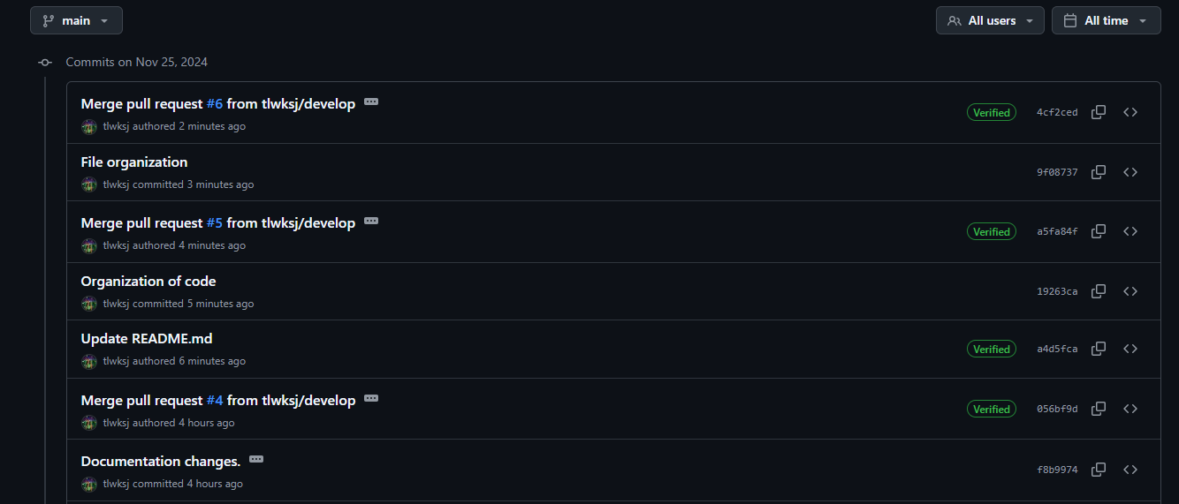

Figure 3: logging for the changes.

As a group we understand the importance of testing before deploying, which is why we created a branch specifically for this, where we can evaluate the changes and fully confirm that the code is done correctly before deploying onto the main branch. Before merging into the test branch, both other group members statically review the code, to ensure that the code is functional before switching branches. We ensure that this does not impact development by allowing the last working version to be the one on main branch until the new feature is assessed and well revised.

Figure 4: Current Branches aside from Main.

The process in which we test our code is divided into three stages: Unit, Integration and Acceptance. We start off by unit testing the code on its own, assuring that the functionality it has is what the requirements ask for. In addition, we review that the code is comprehensible to others that might get involved in the development, and that it is up to the coding standards established. After this testing, the unit is then integrated into a test environment of the system, this way we prevent that our system will collapse in case it does not integrate well. We test the integration of the unit, and that the unit remains equally functional even when it is integrated onto the environment. Finally, once we have guaranteed that this code block works within the application, we have a user acceptance process, making sure that it is able to be used by others outside the developers and that it is accessible.

Going forward, we look for the deployment process to be much more distributed, in which the author of the code does the pull request and upload, while I review and merge into the branches. This had to change for this sprint due to the issues that we had with GitHub but will not be the regular process. Regardless of these issues, the deployment process has been going smoothly, as the workflow of the group is well aligned with each other and no further issues have been encountered.

GitHub link: <https://github.com/tlwksj/cs349nt>